Test Case: tc001_SPX_Dev5_Crear_Requisicion_Spot_Tipo_Cobro_CC
Step 1 - Enter username and password and click to button Enter : Credentials Entered
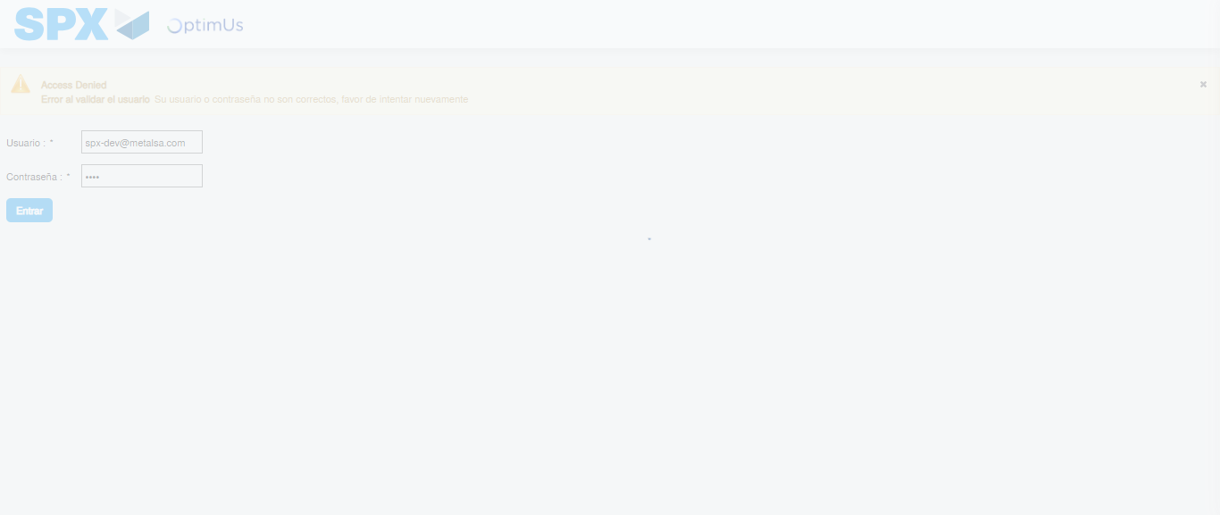Image file-name: QC_Testing-tc001_SPX_Dev5_Crear_Requisicion_Spot_Tipo_Cobro_CC-1783978359021

Step 2 - Select to UEN and Access to Spot Buy Requisitions : UEN Correctly selected and Correct access
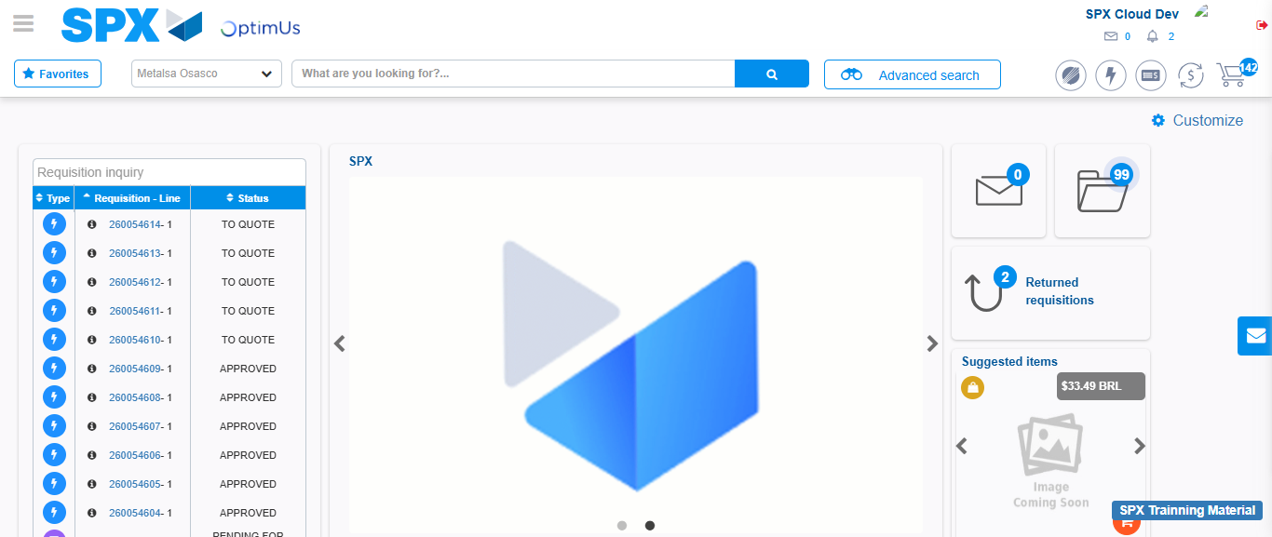Image file-name: QC_Testing-tc001_SPX_Dev5_Crear_Requisicion_Spot_Tipo_Cobro_CC-1783978427639

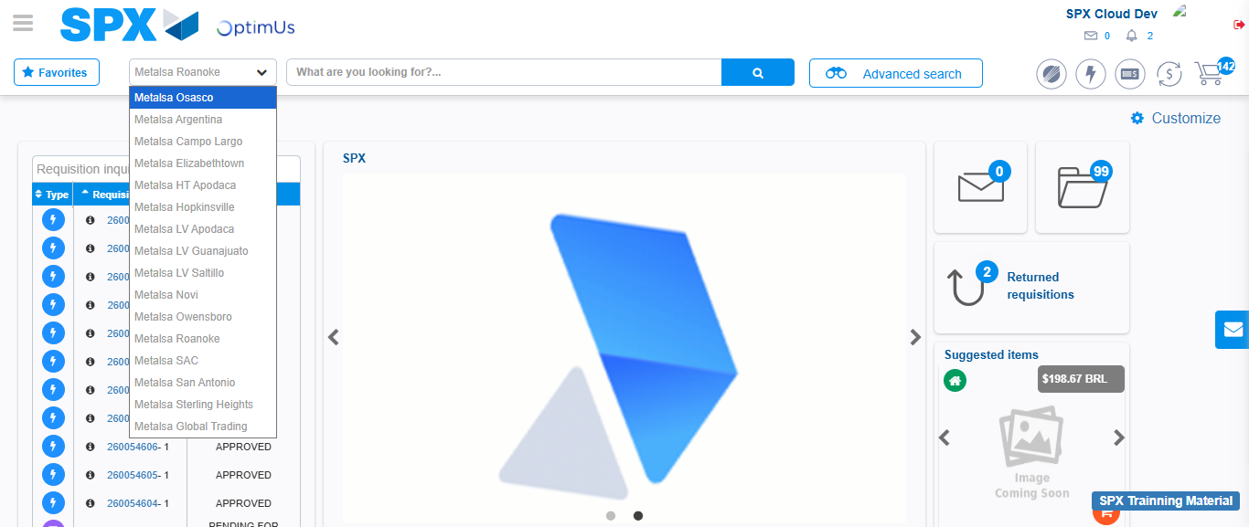Image file-name: QC_Testing-tc001_SPX_Dev5_Crear_Requisicion_Spot_Tipo_Cobro_CC-1783978430273

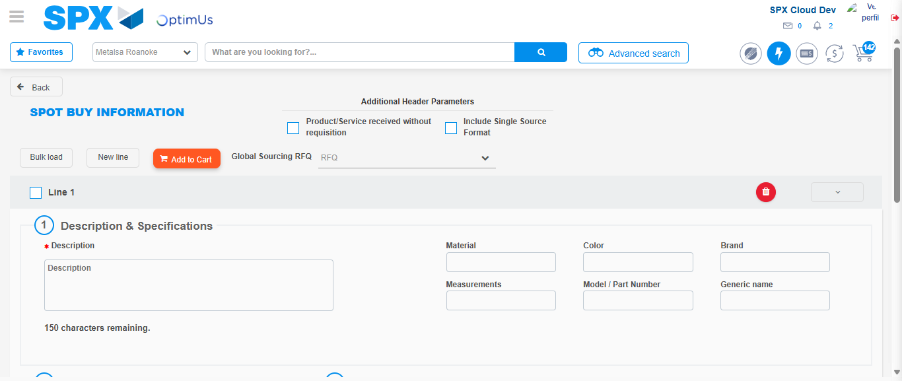Image file-name: QC_Testing-tc001_SPX_Dev5_Crear_Requisicion_Spot_Tipo_Cobro_CC-1783978439121

Step 3 - Data Capture Spot Buy Requisition : Data captured correctly
Image file-name: QC_Testing-tc001_SPX_Dev5_Crear_Requisicion_Spot_Tipo_Cobro_CC-1783978439345

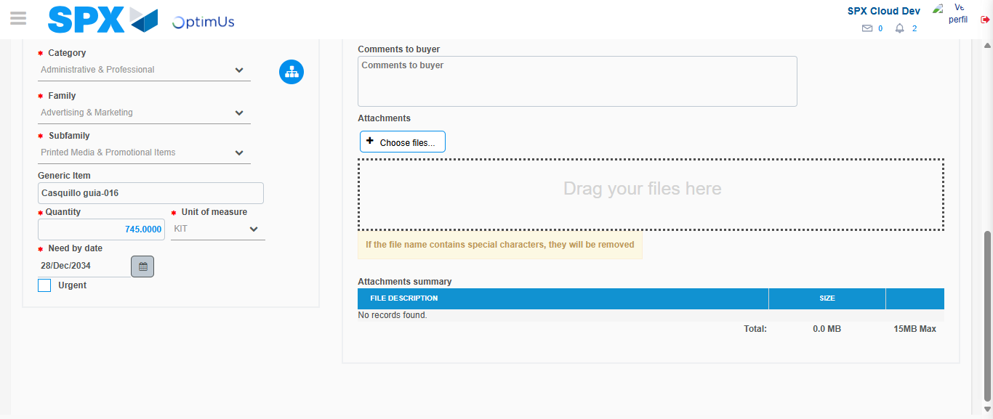Image file-name: QC_Testing-tc001_SPX_Dev5_Crear_Requisicion_Spot_Tipo_Cobro_CC-1783978448926

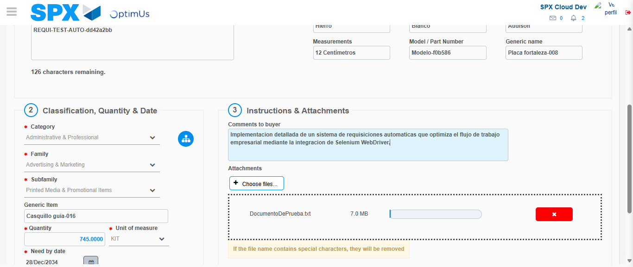Image file-name: QC_Testing-tc001_SPX_Dev5_Crear_Requisicion_Spot_Tipo_Cobro_CC-1783978449667

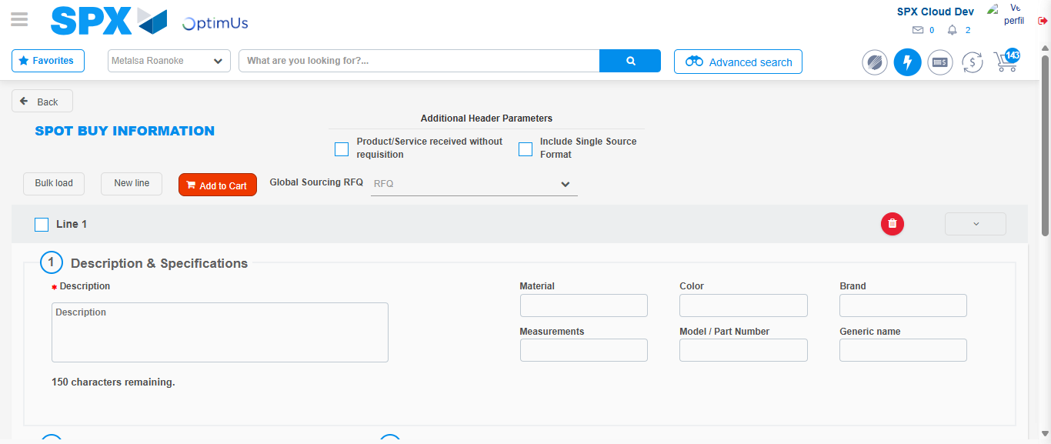Image file-name: QC_Testing-tc001_SPX_Dev5_Crear_Requisicion_Spot_Tipo_Cobro_CC-1783978459111

Step 7 - Return to Main Page SPX : Return to Main Page SPX
Image file-name: QC_Testing-tc001_SPX_Dev5_Crear_Requisicion_Spot_Tipo_Cobro_CC-1783978427639

Image file-name: QC_Testing-tc001_SPX_Dev5_Crear_Requisicion_Spot_Tipo_Cobro_CC-1783978430273

Image file-name: QC_Testing-tc001_SPX_Dev5_Crear_Requisicion_Spot_Tipo_Cobro_CC-1783978439121

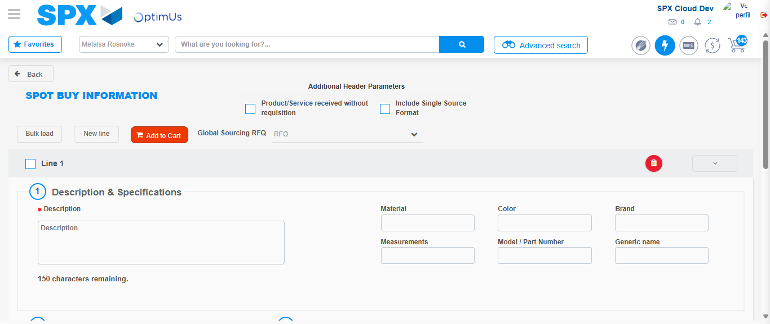Image file-name: QC_Testing-tc001_SPX_Dev5_Crear_Requisicion_Spot_Tipo_Cobro_CC-1783978461302

Image file-name: QC_Testing-tc001_SPX_Dev5_Crear_Requisicion_Spot_Tipo_Cobro_CC-1783978461446

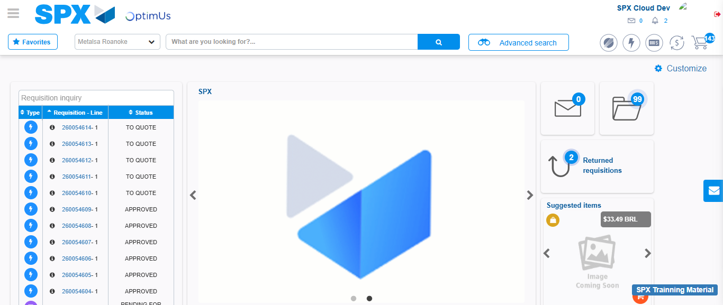Image file-name: QC_Testing-tc001_SPX_Dev5_Crear_Requisicion_Spot_Tipo_Cobro_CC-1783978482474

Step 8 - Log Out : Log Out SPX
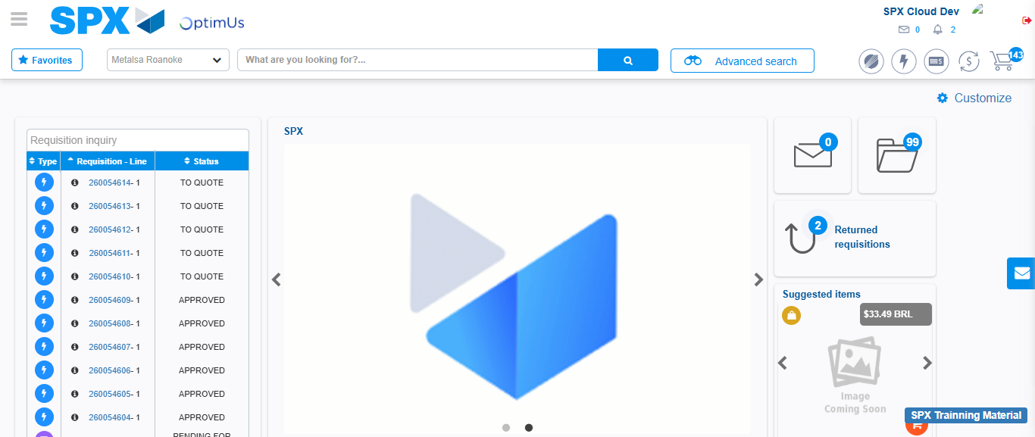Image file-name: QC_Testing-tc001_SPX_Dev5_Crear_Requisicion_Spot_Tipo_Cobro_CC-1783978482742

